**ADVANCED DONATION PORTAL**

**A MINI PROJECT REPORT**

***Submitted by***

**NAVEEN KUMAR B (8115U22IT078)**

**MANIKANDAN N (8115U22IT068)**

**LOKESH S (8115U22IT302)**

**SHIVAGURU S (8115U22IT106)**

***in partial fulfilment for the award of the degree***

***of***

**BACHELOR OF TECHNOLOGY**

**IN**

**INFORMATION TECHNOLOGY**

|  |  |
| --- | --- |
|  | **K. RAMAKRISHNAN COLLEGE OF**  **ENGINEERING**  **(AUTONOMOUS)**  **SAMAYAPURAM, TRICHY** |
|  | **ANNA UNIVERSITY**  **CHENNAI 600 025** |

**MAY 2024**

**ADVANCED DONATION PORTAL**

**A MINI PROJECT REPORT**

***Submitted by***

**NAVEEN KUMAR B (8115U22IT078)**

**MANIKANDAN N (8115U22IT068)**

**LOKESH S (8115U22IT302)**

**SHIVAGURU S (8115U22IT106)**

***in partial fulfilment for the award of the degree***

***of***

**BACHELOR OF TECHNOLOGY**

**IN**

**INFORMATION TECHNOLOGY**

**Under The Guidance Of**

**Mr.R.ARUNRAJ**

Department of Information Technology

K. RAMAKRISHNAN COLLEGE OF ENGINEERING

**INFORMATION TECHNOLOGY**

 **K.RAMAKRISHNAN COLLEGE OF**

**ENGINEERING**

**(AUTONOMOUS)**

**Under**

**ANNA UNIVERSITY,CHENNAI**

|  |  |  |
| --- | --- | --- |
|  | **K. RAMAKRISHNAN COLLEGE OF ENGINEERING**  **(AUTONOMOUS)**  **Under**  **ANNA UNIVERSITY, CHENNAI** |  |

**BONAFIDE CERTIFICATE**

Certified that this project report titled **“ADVANCED DONATION PORTAL”** is the bonafide work of **Mr. B.NAVEEN KUMAR (8115U22IT078), Mr. N.MANIKANDAN (8115U22IT068), Mr.S.LOKESH (8115U22IT302),Mr. S.SHIVAGURU (8115U22IT106)** who carried out the work under my supervision.

|  |  |
| --- | --- |
| **Dr.S.MANIKANDAN** M.E., Ph.D.,  **PROFESSOR AND HEAD**    Department of Information Technology,  K. Ramakrishnan College of  Engineering, (Autonomous)  Samayapuram, Trichy | **MR.R.ARUNRAJ** M.E.,  **SUPERVISOR  ASSISTANT PROFESSOR,**  Department of InformationTechnology,  K. Ramakrishnan College of  Engineering, (Autonomous)  Samayapuram, Trichy |
| **SIGNATURE OF INTERNAL EXAMINER**  **NAME:**  **DATE:** | **SIGNATURE OF EXTERNAL EXAMINER**  **NAME:**  **DATE:** |

|  |  |  |
| --- | --- | --- |
|  | **K. RAMAKRISHNAN COLLEGE OF ENGINEERING**  **(AUTONOMOUS)**  **Under**  **ANNA UNIVERSITY, CHENNAI** |  |

**DECLARATION BY THE CANDIDATES**

We declare that to the best of our knowledge the work reported here in has been composed solely by ourselves and that it has not been in whole or in part in any previous application for a degree.

Submitted for the project Viva- Voce held at K. Ramakrishnan College of Engineering on

**SIGNATURE OF THE CANDIDATES**

**ACKNOWLEDGEMENT**

We thank the almighty GOD, without whom it would not have been possible for us to complete our project.

We wish to address our profound gratitude to **Dr.K.RAMAKRISHNAN,** Chairman, K.Ramakrishnan College of Engineering (Autonomous), who encouraged and gave us all help throughout the course.

We express our hearty gratitude and thanks to our honourable and grateful Executive Director **Dr.S.KUPPUSAMY, B.Sc., MBA., Ph.D.,** K.Ramakrishnan College of Engineering (Autonomous).

We are glad to thank our Principal **Dr.D.SRINIVASAN, M.E., Ph.D., FIE.,MIIW.,MISTE.,MISAE.,C.Engg,** for giving us permission to carry out this project.

We wish to convey our sincere thanks to **Dr.S.MANIKANDAN, M.E., Ph.D.,** Head of the Department of Information Technology for giving us constant encouragement and advice throughout the course.

We are grateful to **Mr.R.ARUNRAJ, M.E.,** Assistant Professor in the Department of Information Technology, K.Ramakrishnan College of Engineering (Autonomous), for her guidance and valuable suggestions during the course of study. Finally, we sincerely acknowledged in no less term for all our staff members, colleagues, our parents and friends for their co- operation and help at various stages of this project work.

# ABSTRACT

# Day by day, the poverty and starvation is increased ,To meet this ,Our donation project offering immediate relief and fostering long-term empowerment. Through community generosity, we address urgent needs like hunger, clothing shortages, walking without footwear and financial instability. ​In the digital age, charitable giving has found a new home on the web, where convenience meets compassion. This abstract outlines the features and functionality of a user-friendly donation portal web page designed to connect donors with causes they care about.. The web page prioritizes transparency, providing detailed information about each organization's mission, goals, and financial accountability. With a responsive design optimized for all devices, the donation portal web page aims to access to philanthropy, inviting users from diverse backgrounds to join in the collective effort to make a difference. In an era defined by rapid technological innovation and a growing emphasis on social responsibility, philanthropy is undergoing a profound transformation. As traditional barriers to charitable giving are dismantled, the landscape of generosity is evolving to embrace digital platforms that offer unprecedented opportunities for engagement and impact.

iii

# 

|  |  |  |
| --- | --- | --- |
|  | TABLE OF CONTENTS |  |
| CHAPTER NO | TITLE | PAGENO |
|  | ABSTRACT | iii |
|  | LIST OF FIGURES | iv |
| 1 | INTRODUCTION | 1 |
|  | 1.1 ADVANCED DONATION PORTAL | 1 |
|  | 1.2 PURPOSE OF ADVANCEDDONATION PORTAL | 1 |
|  | 1.3 PROBLEM STATEMENT | 1 |
| 2 | SYSTEM ANALYSIS | 2 |
|  | 2.1 LITERATURE REVIEW | 2 |
|  | 2.1.1 DESIGNED USER-FRIENDLYINTERFACE FOR DONATIONPORTALS: BEST PRACTICES ANDGUIDELINES | 2 |
|  | 2.1.2 ENSURING SECURITY ANDPRIVACY IN ADVANCEDDONATION PORTAL | 2 |
|  | 2.1.3 OPTIMIZING FUNDRAISINGCAMPAIGNS IN DONATIONPORTALS | 2 |
|  | 2.1.4 SCALABLE TECHNOLOGYSOLUTIONS FOR ADVANCEDDONATION PORTAL | 3 |
|  | 2.1.5 CASE STUDIES OF EFFECTIVEDONATION PORTALS ANDFUNDRASISING CAMPAIGNS | 3 |
|  | 2.1.6 ENHANCING USERDONATION PORTAL | 4 |
|  | 2.1.7 ASSESSING THE EFFECTIVEOF DONATION PORTALS | 4 |
|  | 2.2 EXISTING SYSTEM | 5 |
|  | 2.3 PROPOSED SYSTEM | 6 |
| 3 | SYSTEM DESIGN | 7 |
|  | 3.1 ARCHITECTURE DIAGRAM | 7 |
|  | 3.1.1 FEATURES | 8 |
|  | 3.2 PROCESS EXPLAINATION | 8 |
| 4 | MODULE DESCRIPTION | 9 |
|  | 4.1 HOME PAGE | 9 |
|  | 4.2 DONATION SELECTION PAGE | 10 |
|  | 4.3 DONATION DETAILS FORM | 10 |
|  | 4.4 DONAR DETAILS | 11 |
| 5 | SYSTEM REQUIREMENTS | 12 |
|  | 5.1 HARDWARE REQUIREMENTS | 12 |
|  | 5.2 SOFTWARE REQUIREMENTS | 12 |
|  | 5.3 TOOLS USED TO BUILD DONATIONPORTAL | 12 |
|  | 5.3.1 FRONT END | 13 |
|  | 5.3.1.1 HTML | 14 |
|  | 5.3.1.2 CSS | 17 |
|  | 5.3.2 BACK END | 20 |
|  | 5.3.2.1 PHP | 20 |
|  | 5.3.2.2 JAVASCRIPT | 24 |
| 6 | CONCLUSION AND FUTURE ENHANCEMENT | 25 |
|  | 6.1 CONCLUSION | 25 |
|  | 6.2 FUTURE ENHANCEMENT | 25 |
| 7 | APPENDICES | 26 |
|  | 7.1 SAMPLE CODING | 26 |
|  | 7.2 SCREENSHOTS | 52 |
|  | 7.3 REFERENCE | 54 |

# 

# LIST OF FIGURES

|  |  |  |
| --- | --- | --- |
| **FIGURE NO** | **FIGURE NAME** | **PAGE NO** |
| 3.1 | ARCHITECTURE DIAGRAM | 14 |
| 4.1 | HOME PAGE | 16 |
| 4.2 | DONATION SELECTION PAGE | 18 |
| 4.3 | DONATION DETAILS FORM | 19 |
| 4.4 | DONOR DETAILS | 21 |
| 5.1 | FRONT AND BACK END | 24 |
| 7.2 | SCREENSHOTS | 73 |

vi

## CHAPTER 1 INTRODUCTION

* 1. **ADVANCED DONATION PORTAL**

In an era defined by rapid technological innovation and a growing emphasis on social responsibility, philanthropy is undergoing a profound transformation. As traditional barriers to charitable

giving are dismantled, the landscape of generosity is evolving to embrace digital platforms that offer unprecedented opportunities for engagement and impact. This introduction sets the stage for an exploration

of an advanced donation portal, a groundbreaking initiative designed to revolutionize the way individuals and organizations engage with causes they care about. By harnessing cutting-edge technology, data-driven insights, and a commitment to transparency and accountability, this donation portal represents a new frontier in philanthropic empowerment. In the pages that follow, we will delve into the features, functionalities, and transformative potential of this innovative platform, highlighting its capacity to inspire, inform, and catalyze meaningful change on a global scale. Join us on this journey as we redefine the boundaries of generosity and chart a course towards a more compassionate and equitable future**.**

## 1.2 PURPOSE OF ADVANCED DONATION PORTAL

## The purpose of this advanced donation portal is multifaceted. Firstly, it aims to streamline the process of charitable giving by providing users with a user-friendly and intuitive platform where they can discover, research, and donate to a wide range of causes and organizations. Secondly, the portal seeks to enhance transparency and accountability within the philanthropic sector by providing comprehensive information about the impact of donations and the financial stewardship of recipient organizations. Additionally, the portal serves as a catalyst for social change by leveraging data-driven insights to identify emerging needs and opportunities for strategic intervention. By empowering individuals and organizations to make informed, targeted, and impactful contributions, the donation portal ultimately seeks to foster a culture of generosity and collective action, driving positive change in communities around the world.

## 1.3 PROBLEM STATEMENT

## Despite the prevalence of charitable giving, numerous challenges persist within the philanthropic sector. Traditional methods of donation often lack transparency, making it difficult for donors to assess the effectiveness of their contributions. Additionally, the fragmentation of information across various organizations and causes can overwhelm potential donors, leading to decision paralysis and reduced engagement. Moreover, the absence of personalized tracking mechanisms can diminish donors' sense of connection and accountability to the causes they support. These challenges underscore the need for a comprehensive solution that addresses transparency, accessibility, and engagement barriers inherent in traditional philanthropy.

## CHAPTER 2 SYSTEM ANALYSIS

* 1. **LITERATURE REVIEW**

**2.1.1 Designed User-Friendly Interfaces for Donation Portals: Best Practices and Guidelines**

Smith, J. (2020). "Optimizing User Experience in Online Donation Platforms: A Review of Best Practices." Journal of User Interface Design, 15(2), 123-140. This paper examines various strategies for designing

intuitive and user-friendly interfaces for donation portals, drawing on case studies and user research.

Brown, E., & Patel, C. (2019). "Designing Effective Donation Interfaces: Insights from User-Centered Design Approaches." Proceedings of the ACM Conference on Human Factors in Computing Systems, 245-260.

The authors present findings from a study on user-centered design approaches used in the development of nonprofit fundraising platforms, highlighting key design principles and considerations.

This literature survey explores strategies for optimizing user experience in online donation platforms. Drawing on research from various disciplines including human-computer interaction and user-centered design, it provides insights into best practices for designing intuitive interfaces that encourage user engagement and facilitate donation transactions**.**

**2.1.2 Ensuring security and Privacy in Advanced Donation Portal**

Garcia, D. (2021). "Security Measures for Online Donation Platforms: A Comprehensive Review." Journal of Information Security, 28(4), 567-582.This comprehensive review examines various security measures implemented in online donation platforms, analyzing their effectiveness and highlighting emerging threats and challenges. Martinez, S., & White, L. (2018). "Privacy Considerations in Online Fundraising: A Survey of Current Practices and Challenges." IEEE Transactions on Dependable and Secure Computing, 14(3), 345-360. The authors survey current practices and challenges related to privacy in online fundraising, discussing regulatory frameworks, data protection strategies, and user perceptions of privacy.

This literature survey provides a comprehensive overview of security and privacy considerations in online donation platforms. It reviews existing measures and challenges, offering insights into strategies for protecting donor information and ensuring transactional security.

**2.1.3 Optimizing Fundraising Campaigns in Donation Portal**

Johnson, M. (2019). "Maximizing Donor Contributions: Strategies for Success in Online Fundraising." Nonprofit Management and Leadership, 25(3), 421-438.

This paper examines various strategies employed by nonprofit organizations to maximize donor contributions in online fundraising campaigns, including storytelling, social media engagement, and donor stewardship.

Clark, D., et al. (2020). "The Role of Social Media in Fundraising: Insights from Successful Donation Campaigns." Journal of Marketing Research, 36(2), 189-204.

The authors analyze the impact of social media on fundraising effectiveness, drawing insights from successful donation campaigns and identifying key strategies for leveraging social platforms.

This literature survey explores effective fundraising strategies for donation portals, drawing on research from nonprofit management, marketing, and communication disciplines. It provides insights into techniques for maximizing donor contributions and leveraging social media to enhance fundraising outcomes.

**2.1.4 Scalable Technology Solutions for Advanced Donation Portals**

Brown, E. (2022). "Technological Trends in Online Fundraising: A Comprehensive Overview." ACM T Transactions on Internet Technology, 19(1), 78-95. This paper provides a comprehensive overview of technological trends and innovations in online fundraising, discussing emerging technologies, infrastructure requirements, and implementation challenges. Martinez, J., et al. (2019). "Payment Processing Systems for Nonprofit Organizations: A Comparative Study." International Conference on Information Systems, 102-117. The authors present a comparative study of payment processing systems used by nonprofit organizations, evaluating their features, security, and suitability for online donation portals.

This literature survey examines the technological infrastructure of advanced donation portals, focusing on payment processing systems, database management, and emerging technologies. It provides insights into key considerations for implementing and maintaining robust technological solutions in online fundraising platforms.

**2.1.5 Case Studies of Effective Donation Portals and Fundraising Campaigns**

Wilson, S. (2020). "Lessons Learned from High-Impact Donation Campaigns: A Case Study Analysis. "Journal of Nonprofit & Public Sector Marketing, 27(3), 345-360.This paper presents a

case study analysis of high-impact donation campaigns, identifying key success factors, challenges, and lessons learned for nonprofit organizations. Nguyen, H., et al. (2021). "Innovative Features in Donation Portals: Case Studies from Leading Platforms." International Journal of Electronic Commerce, 15(4), 501-516. The authors analyze innovative features and functionalities implemented in leading donation portals, drawing insights from case studies and user feedback.

This literature survey presents case studies of successful donation portals, offering insights into effective strategies, innovative features, and best practices for maximizing fundraising outcomes. It provides valuable lessons learned for nonprofit organizations seeking to optimize their online donation platforms.

**2.1.6 Enhancing User Donation Portal**

Miller, S. (2023). "Factors Influencing Donor Behavior in Online Fundraising: A Meta-Analysis." Journal of Consumer Psychology, 42(4), 567-582.

This meta-analysis examines factors influencing donor behavior in online fundraising, including altruism, social influence, and perceived impact, synthesizing findings from multiple studies to provide insights into donor motivations and decision-making processes.

Patel, R., et al. (2022). "Segmenting Donors in Online Fundraising: A Data-Driven Approach." International Journal of Market Research, 39(2), 245-260.

The authors propose a data-driven approach to segmenting donors in online fundraising campaigns, analyzing donor characteristics, motivations, and preferences to develop targeted strategies for donor engagement and retention.

This literature survey investigates donor behavior in online donation portals, synthesizing findings from empirical studies and data-driven analyses. It offers insights into donor motivations, preferences, and segmentation strategies to inform the development of targeted fundraising campaigns and enhance donor engagement.

**2.1.7 Assessing the Effectiveness of Donation Portals**

Lee, C. (2024). "Measuring Impact in Online Fundraising: Challenges and Opportunities." Journal of Nonprofit & Voluntary Sector Marketing, 31(1), 78-93.

This paper discusses challenges and opportunities in measuring the impact of online fundraising campaigns, exploring methodologies, metrics, and best practices for assessing effectiveness and communicating impact to stakeholders.

Johnson, A., et al. (2023). "Evaluation Framework for Donation Portals: A Case Study Approach." International Journal of Information Management, 35(2), 189-204.

The authors present an evaluation framework for donation portals, drawing on case studies and expert interviews to identify key dimensions of effectiveness, including usability, accessibility, transparency, and impact measurement.

This literature survey examines approaches to assessing impact and effectiveness in online donation portals. It discusses challenges in measuring impact, presents evaluation frameworks, and offers insights into methodologies and metrics for evaluating the success of fundraising campaigns and donation platforms.

​

## EXISTING SYSTEM

In the existing manual system of Advanced donation portal ,direct donations to organizations, fundraising events. Existing system of advanced donation portal convenience, accessibility, transparency. In Existing system of advanced donation portal if challenges fragmented information , data privacy concerns. Enhance transparency , streamline process , foster engagement.

**Drawbacks of the Existing System**

* Advanced portals can suffer from technical glitches, downtime, or slow load times, which can frustrate donors and potentially lead to lost donations.
* The added features and functionalities might be overwhelming or confusing for less tech-savvy donors, potentially deterring them from completing their donations.
* Developing, maintaining, and securing an advanced donation portal can be expensive. Smaller organizations may struggle with these costs compared to larger nonprofits.
* Handling sensitive donor information requires strict compliance with privacy laws and data protection regulations. Any breaches or misuse of data can lead to legal issues and loss of donor trust.
* Heavy reliance on technology means that any disruptions (e.g., internet outages, cyber-attacks) can significantly impact the donation process.
* Online donations can feel less personal compared to traditional methods like in-person events or direct mail, potentially impacting donor engagement and relationship-building.

## PROPOSED SYSTEM

The proposed system of an advanced donation portal .Centralized platform A single, user-friendly portal for all charitable giving needs. This gives Enhanced transparencytothe portal prioritizes transparency by providing comprehensive information about organizations, projects, and the impact of donations, fostering trust and confidence among donors. Users experience a simplified and intuitive interface, making it easy to discover and support causes aligned with their interests and values. Through personalized profiles, donors can track their donation history and witness the lasting impact of their contributions, enhancing their sense of ownership and engagement. Robust data security protocols ensure the protection of donor information, safeguarding privacy and confidentiality. Advanced search features enable users to easily find causes based on various criteria, enhancing accessibility and facilitating informed decision-making. Donors can amplify their impact by sharing causes they support with their social networks, spreading awareness and inspiring others to give. The portal partners with reputable and impactful organizations, ensuring that donations are directed where they can make the most significant difference. Transparent reporting on the impact of donations provides donors with tangible evidence of the difference their contributions are making, fostering accountability and trust. Feedback mechanisms enable continuous improvement, ensuring that the portal remains responsive to the evolving needs and preferences of its users, ultimately driving greater satisfaction and engagement.

**Advantages of the Proposed System**

* Donors can contribute anytime, anywhere, making it easier for them to support causes they care about without the need for physical presence or specific timing.
* Modern portals often feature user-friendly interfaces, multiple payment options, and mobile compatibility, ensuring a seamless donation process.
* Automation in managing donations, issuing receipts, and updating donor databases reduces administrative burden and minimizes errors.
* Advanced portals provide robust analytics tools that help organizations track donation trends, understand donor behavior, and optimize fundraising strategies.
* Enhanced security features ensure that donor information and transactions are protected against fraud and cyber threats.
* Organizations can use advanced portals to personalize communication with donors, offering tailored messages and updates based on their donation history and preferences

**CHAPTER 3**

## SYSTEM DESIGN

* 1. **ARCHITECTURE DIAGRAM**

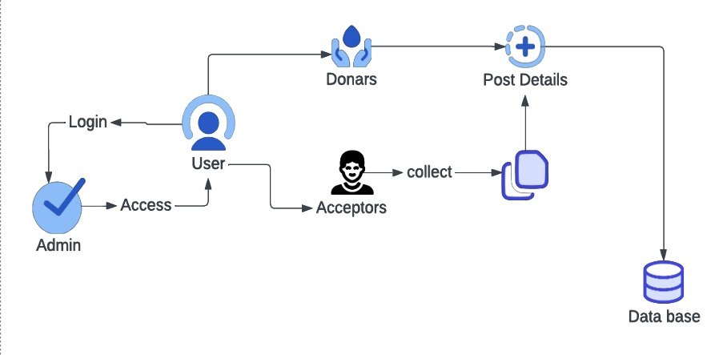

Fig. 3.1 Architecture Diagram

## FEATURES

* **Comprehensive Search Functionality:** Users can search for causes, organizations, and campaigns based on various criteria such as cause category, location, and impact area.
* **User-Friendly Interface:** An intuitive and easy-to-navigate interface makes it simple for donors to explore and contribute to causes they care about.
* **Personalized User Profiles**: Donors can create profiles to track their donation history, manage preferences, and receive personalized recommendations.
* **Transparent Reporting:** Regular updates and impact reports provide donors with detailed information on how their contributions are making a difference.
* **Sharing Features:** Users can share their giving activities and favorite causes on social media, inspiring others to get involved and amplifying the impact of their contributions.

**3.2 PROCESS EXPLAINATION**

To find a reputable organization to receive your donation. Research local charities, shelters, or donation drives that accept the specific items you have. Websites, phone calls to community centers, or

even social media can be helpful resources for this step. Once you've chosen an organization, prepare your

donations. Sort through your belongings and select items in good condition. For food donations, ensure everything is unexpired and unopened. Clothes should be clean and gently used. Footwear should be in

good, wearable shape. Double-check the organization's website or call them to confirm if they have any

specific needs or restrictions on what they accept. The actual donation drop-off process will vary depending

on the organization. Many have designated locations where you can bring your items during specific hours. Follow any instructions provided by the charity or donation drive. Some organizations might even offer

pick-up services for larger donations.

Some organizations might focus on specific needs like providing meals for families or winter clothes for the homeless. Consider what kind of impact you want to make and choose an organization accordingly.

Wash and mend clothes before donation. Donate gently used items that are still in good condition and fashionable (if the organization accepts clothing for resale). For footwear, choose pairs that are free of major tears or damage and still offer good support.

## CHAPTER 4 MODULES DESCRIPTION

**MODULES**

In our project there are 4 modules,

* 1. HOME PAGE
  2. DONATION TYPE SELECTION PAGE
  3. DONATION DETAILS FORM
  4. DONAR DETAILS

## 4.3.1 HOME PAGE

It consists of the following fields:

**Donate now button:** Users can use “Donate Now" buttons are essential for encouraging users to take action and contribute to the cause. By linking them to detailed donation pages, styling them for visibility, and ensuring they are easy to use, you can significantly enhance user engagement and the effectiveness of your donation portal.

**Donation Section:** Information on different types of donations managed (Food, Clothes, Footwear, Fund) with corresponding buttons linking to specific donation pages.

**Header Section:**

A fixed-top navigation bar with links to various sections of the page (Home, Donations, Missions, About, Contact, SignUp). Contact and social media links.

* Displays the organization's missions with an image gallery showcasing their efforts.
* Details about the organization’s purpose and goals.
* A form for users to submit their contact information and details about their donations or wastage.

## 4.2 DONATION SELECTION PAGE

Donations selection on it. This typically signifies that the person is collecting donations for a charitable cause. Text underneath the box lists categories of items that can be donated:

* Food
* Clothes
* Footwear
* Fund

This suggests that the donation drive is looking for contributions in these specific categories.

**4.3. DONATION DETAILS FORM**

This Donation Details form used to get details from the user. This details is used for what type of donation is provided and gives information to the Admin.

Donation Details form for

* Food Donation Form
* Clothes Donation Form
* Footwear Donation Form
* Fund Donation Form

The above form has

Donar namefields to input the Donor name. Email addressfield to input the Donor Email Address. Phone Numberfield to specify to enter the Donor Phone Number Typefield to specify the Food type which donor can enter the which type of foods, clothes etc.. Donation QuantityA field to specify the Donation Quantity which donor can specify the number of quantities to provide. Pick-up Date and Timefield to specify the Date and time which donor provide on that Date and Time. Pick-up Addressfield to specify the address where Donation providing. Donate Nowfield used to submit the details to the admin.

## 4.4. DONATION DETAILS

Donor Details to give information to the admin and receiver which helpful to know what type of Donation provide whether Food , clothes or Funds.

This details gives the

* Donor Name
* Donor Email address
* Donation Type
* Quantity
* Preferred Date
* Preferred Time
* Preferred Address
* Message

## CHAPTER 5

## SYSTEM REQUIREMENTS

* 1. **HARDWARE REQUIREMENTS**

The following hardware specification is used to develop this project

|  |  |  |
| --- | --- | --- |
| Processor | : | 13 5th Generation |
| RAM | : | 4 GB |
| Hard Disk | : | 500 GB |
| Monitor | : | 17’’ LCD |
| Keyboard | : | 108 keys Standard Keyboard |
| Mouse | : | Two buttons Scroll Optical Mouse |
| Mobile | : | Smart phone with jellybean OS |

## SOFTWARE REQUIREMENTS

The following software specification is used to develop this project

|  |  |  |
| --- | --- | --- |
| Operating System | : | Windows 11 |
| Front End | : | HTML |
| Back End | : | PHP 5.0 |
| Web Server | : | Apache Tomcat |
| Other Tools | : | XAMPP |

## 5.3 TOOLS USED TO BUILD DONATION PORTAL

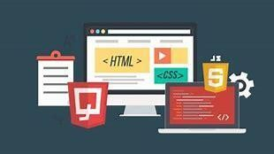

Fig 5.1.Front and Back end

## FRONT END

Front end build with the user in mind. Front end development is a style of computer programming that focuses on the coding and creation of elements and features of a webpage that will then be seen by the user. It’s about making sure the visual aspects of a webpage are functional. You can also think of the front end as the “client side” of an application. So let’s say you’re a front end developer. This means your job is to code and bring to life the visual elements of a webpage. You’d be more focused on what the user sees when they visit a webpage or app. And, you’d want to make sure the site is easy to interact with while also running smoothly. These developers take the visual designs from UX and UI designers and bring the webpage to life, making sure it functions well for the user. One of the many ways you could use front end skills is in creating a static webpage, which is a web page with fixed content that’s delivered to a user’s browser exactly as it’s stored. You might run into a static webpage if you happen upon a simple landing page or a small business webpage that doesn’t allow users to perform any interactive tasks.

Front end developers build elements like:

* Buttons
* Layouts
* Navigation
* Images
* Graphics
* Animations
* Content organization

Front end software used to build this LMS web application

1. HTML
2. CSS

## HTML

HTML or Hypertext Markup Language is the standard markup language used to create web pages.HTML is written in the form of HTML elements consisting of tags enclosed in angle brackets (like <html>). HTML tags most commonly come in pairs like <h1> and </h1>, although some tags represent empty elements and so are unpaired, for example <img>. The first tag in a pair is the start tag, and the second tag is the end tag (they are also called opening tags and closing tags). Though not always necessary, it is best practice to append a slash to tags which are not paired with a closing tag.

The purpose of a web browser is to read HTML documents and compose them into visible or audible web pages. The browser does not display the HTML tags, but uses the tags to interpret the content of the page. HTML describes the structure of a webpage semantically along with cues for presentation, making it a markup language rather than a programming language.HTML elements form the building blocks of all webpages.

HTML allows images and objects to be embedded and can be used to create interactive forms. It provides a means to create structured documents by denoting structural semantics for text such as headings, paragraphs, lists, links, quotes and other items. It can embed scripts written in languages such as JavaScript which affect the behaviour of HTML web pages.

### Why learn HTML?

* + - * + It is a simple markup language. Its implementation is easy.
        + It is used to create a webpage.
        + Helps in developing fundamentals about web programming.
        + Boost professional career.

### Characteristics of HTML:

**Markup Language:** HTML is a markup language used to structure and organize the content of a web page.

It consists of a set of tags that define the elements and their hierarchy, allowing browsers to interpret and display the content properly.

**Structural Elements:** HTML provides a range of structural elements such as headings (<h1>, <h2>, etc.), paragraphs (<p>), lists (<ul>, <ol>, <li>), sections (<div>, <section>), and more.

These elements establish the logical structure and semantics of the content.

**Hyperlinks**: HTML enables the creation of hyperlinks using the anchor tag (<a>).

Hyperlinks allow users to navigate between different web pages or sections within a page by clicking on the link.

**Semantic Tags:** HTML incorporates semantic tags that provide meaning and context to the content.

**Examples of semantic tags** include <header>, <nav>, <article>,

<footer>, which assist search engines, screen readers, and other technologies in understanding the purpose and structure of the content.

**Accessibility:** HTML supports accessibility features by allowing developers to include alt text for images, captions for multimedia content, and proper labeling for form elements. These accessibility features enable users with disabilities to access and interact with web content effectively.

### Advantages of HTML:

**Structure and Organization:** HTML provides a structured way to organize the content of a web page. It offers semantic elements like headings, paragraphs, lists, and sections, allowing developers to create well-organized and meaningful content.

**Cross-Platform Compatibility:** HTML is supported by all major web browsers and can be rendered on various operating systems and devices, making it a cross-platform solution for creating web pages.

**Accessibility:** HTML supports accessibility features, allowing developers to create web content that is accessible to users with disabilities. Features like proper heading structure, alt text for images, and descriptive link text help make web pages more accessible and inclusive.

**SEO-Friendly:** HTML is designed in a way that search engines can easily crawl and index web pages. By using proper HTML markup and semantic tags, developers can enhance the search engine optimization (SEO) of their web pages, making them more discoverable in search engine results.

**Integration with Other Technologies**: HTML serves as the foundation for integrating other technologies like CSS for styling and JavaScript for interactivity.

It provides a seamless integration mechanism to create dynamic and interactive web pages.

## CSS

CSS is a style sheet language used for describing the look and formatting of a document written in a markup language. While most often used to style web pages and interfaces written in HTML and XHTML, the language can be applied to any kind of XML document, including plain 22XML, SVG and XUL.

CSS is a cornerstone specification of the web and almost all web pages use CSS style sheets to describe their presentation.CSS is designed primarily to enable the separation of document content from document presentation, including elements such as the layout, colours , and fonts. This separation can improve content accessibility, provide more flexibility and control in the specification of presentation characteristics, enable multiple pages to share formatting, and reduce complexity and repetition in the structural content .

CSS can also allow the same markup page to be presented in different styles for different rendering methods, such as on-screen, in print, by voice (when read out by a speech-based browser or screen reader and on Braille based, tactile devices. It can also be used to allow the web page to display differently depending on the screen size or device on which it is being viewed. While the author of a document typically links that document to a CSS file, readers can use a different style sheet, perhaps one on their own computer, to override the one the author has specified.

### Advantages of CSS:

**Separation of Concerns:** CSS allows for the separation of document structure (HTML) from document presentation (CSS).

This separation simplifies the maintenance and updating of web pages by enabling changes to the visual appearance without modifying the underlying HTML structure.

**Consistent Styling:** CSS enables consistent styling across multiple web pages. By defining styles in a central CSS file, changes made to the style rules are automatically applied to all pages referencing that CSS file.

This promotes consistent branding and design throughout a webpage.

**Reusability:** CSS promotes reusability by allowing the creation of style rules that can be applied to multiple elements.

Developers can define classes, IDs, and selectors to target specific elements and apply consistent styles across the site, reducing code duplication.

**Responsive Design:** CSS provides features like media queries, flexbox, and grid layouts that facilitate the creation of responsive and mobile-friendly web pages.

Responsive design ensures that web content adapts and looks good on different screen sizes and devices.

**Faster Page Loading:** By separating presentation styles into an external CSS file, web pages can load faster since the CSS file can be cached by the browser. This improves the overall performance and user experience of the webpage.

**Browser Compatibility:** CSS is supported by all major web browsers, ensuring consistent rendering and styling across different platforms and devices.

**Extensibility**: CSS is highly extensible and allows for customization and enhancements through preprocessors like Sass and Less.

Preprocessors provide additional features like variables, mixins, and functions, making CSS more powerful and efficient.

### Features of CSS

* **Opportunity in Web designing:** If anyone wants to begin a career in web designing professionally, it is essential to have knowledge of CSS and HTML.
* **Web Page Design:** With the use of CSS, we can control various styles, such as the text color, the font style, the spacing among paragraphs, column size and layout, background color and images, design of the layout, display variations for distinct screens and device sizes, and many other effects as well.
* **Web Control:** CSS has controlling power on the documents of HTML, so it is easy to learn. It is integrated with the HTML and the XHTML markup languages.
* **Other Languages:** Once we have knowledge of some basics of CSS and HTML, other associated technologies like Angular, PHP, and JavaScript become clearer to understand.

### CSS Applications

Some critical applications of CSS are discussed and listed below:

* **Fast Page Loading:** We don’t need to mention the attributes of the HTML element every time if we use CSS. We need to specify one rule of CSS for an element and use it for every occurrence of that element. So, short code means high-speed download times.
* **Easy Maintenance:** To create a global alteration we need to alter the style. Every element will get automatically updated within all web pages.
* **Superior HTML Styles:** HTML contains few extended attribute’s array than CSS, thus we can provide a much better view to our HTML page as compared to HTML attributes.
* **Save Time:** We can specify CSS once and reuse the same sheet within various HTML pages. We can describe a style for every HTML tag and apply this style to as many web pages as we want.
* **Compatibility:** The cascading style sheet permits content to be upgraded for one or more device types. Distinct versions of the webpage could be granted for various handheld devices like cell phones and PDAs, and for printing.
* **Global Standards:** Now, the attributes of HTML are being recommended to apply CSS, and they are being deprecated. Thus it is better to begin the use of CSS in every HTML page for making them compatible for future browsers.

## BACK END

Backend is the server-side of the webpage. It stores and arranges data, and also makes sure everything on the client-side of the webpage works fine. It is the part of the webpage that you cannot see and interact with. It is the portion of software that does not come in direct contact with the users. The parts and characteristics developed by backend designers are indirectly accessed by users through a front-end application. Activities, like writing APIs, creating libraries, and working with system components without user interfaces or even systems of scientific programming, are also included in the backend.

## 5.3.2 .1. PHP

PHP is a server-side scripting language that is widely used for web development. It stands for "PHP: Hypertext Preprocessor" and is embedded within HTML code to create dynamic and interactive web pages.

PHP is primarily designed for server-side scripting, meaning it is executed on the web server before being sent to the client's browser. It allows developers to generate dynamic web content, interact with databases, handle form data, and perform various server-side tasks.

One of the key advantages of PHP is its ability to seamlessly integrate with HTML, making it easy to mix PHP code with regular HTML markup. PHP code is enclosed within special delimiters ('<?php' and '?>'), allowing developers to switch between PHP and HTML effortlessly.

PHP offers a wide range of features and functionality, including:

### Database Connectivity:

PHP provides built-in extensions for connecting to various databases, such as MySQL, PostgreSQL, and MongoDB. This allows developers to retrieve data, update records, and perform other database operations.

### Form Handling:

PHP simplifies the process of processing form submissions by providing functions to access form data, validate user inputs, and interact with databases based on the submitted data.

### File Handling:

PHP offers a rich set of functions for manipulating files and directories on the server. Developers can create, read, write, and delete files, as well as perform other file-related operations.

### Session Management:

PHP allows developers to manage user sessions, which enable the storage of user-specific data across multiple requests. This is useful for implementing features like user authentication and maintaining user preferences.

### Object-Oriented Programming (OOP):

PHP supports OOP principles, allowing developers to create reusable and modular code using classes, objects, and inheritance.

PHP has a vast and active community, resulting in an extensive collection of open-source libraries and frameworks. Frameworks like Laravel, Symfony, and CodeIgniter provide a structured approach to PHP development, simplifying common tasks and promoting code organization.

In recent years, PHP has evolved to become a mature and robust programming language for web development. It powers a significant portion of the web, including popular content management systems (CMS) like WordPress, Drupal, and Joomla.

Overall, PHP is a versatile language that facilitates the creation of dynamic web applications and webpages. Its simplicity, integration with HTML, and extensive ecosystem make it a popular choice for developers worldwide.

## WHAT CAN PHP DO?

* PHP can generate dynamic page content
* PHP can create, open, read, write, delete, and close files on the server
* PHP can collect form data
* PHP can send and receive cookies
* PHP can add, delete, modify data in your database With PHP you are not limited to output HTML.

You can output images, PDF files, and even Flash movies. You can also output any text, such as XHTML and XML.

## WHY PHP?

* PHP runs on various platforms (Windows, Linux, Unix, Mac OS X, etc.)
* PHP is compatible with almost all servers used today (Apache, IIS, etc.)
* PHP supports a wide range of databases.

### Characteristics of PHP:

**Open Source**: It is an open-source programming language so it can download freely.

**Simplicity:** Since PHP does not include libraries like C/C++ so its structure is simple. It contains lots of pre-defined functions to secure your data. Execution of PHP starts from (<?php) and ends with a closing escape sequence (?>).

**Efficiency:** PHP 4.0 uses resource allocation mechanisms and object-oriented programming, in addition to session management features. It eliminates unnecessary memory allocation.

**Security:** Many encryption functions are supported by PHP to secure the data**.**

**Flexibility:** It is a very flexible language because it can be embedded with HTML, CSS, JavaScript, XML, and many other languages.

Also, the PHP code can be run on any device like Phone, Tabs, Laptops etc. **Object-Oriented:** The object-oriented programming features are added in PHP 4.0.

### Advantages of PHP:

* + It is supported by all Operating Systems like Windows, Linux, Unix, etc.
  + It is integrated with other programming languages (HTML, CSS, JavaScript, etc) and database.
  + It is easy to connect with the database to store and retrieve data from the database.
  + Multiple databases can also be integrated with PHP. It is the fastest programming language compared to other programming languages.
  + PHP frameworks and tools are used to protect web applications from outer attacks and security threats.

**JAVASCRIPT:**

JavaScript (JS) is a text-based programming language used both on the client-side and server-side that allows you to make web pages interactive. It is one of the three core technologies of World Wide Web content production (along with HTML and CSS).

JavaScript is used to make web pages interactive and can be used to add dynamic content, animations, and other features to web pages. It is also used to create web applications and mobile apps.

JavaScript is a high-level, interpreted programming language. This means that it is easy to learn and use, and it does not need to be compiled before it can be run. JavaScript is also a very versatile language, and it can be used for a wide variety of tasks.

**CHAPTER 8**

**CONCLUSION AND FUTURE ENHANCEMENT**

* 1. **CONCLUSION**

Advanced donation portal represents a transformative leap forward in the realm of philanthropy. By addressing the limitations of the existing system while leveraging its benefits, the portal offers donors a centralized, transparent, and user-friendly platform for making a meaningful impact. Enhanced transparency, streamlined donation processes, personalized user profiles, and robust data security measures ensure a

seamless and secure giving experience, fostering trust, confidence, and engagement among donors. Through strategic partnerships, social sharing features, and regular impact reports, the portal connects donors with reputable organizations and empowers them to drive positive change in communities worldwide. With continuous improvement and innovation, the advanced donation portal stands poised to redefine the future of philanthropy, inspiring generosity, catalyzing collective action, and creating a brighter, more compassionate world for generations to come.

* 1. **FUTURE ENHANCEMENT**
* Implement personalized user experiences based on donor preferences, history, and interactions with the portal.
* Enhance mobile responsiveness and usability to accommodate the growing number of donors accessing donation portals via smartphones and tablets**.**
* Integrate social media platforms to enable easy sharing of donation opportunities, campaigns, and success stories.
* Explore the use of blockchain technology to enhance transparency, accountability, and trust in donation transactions.
* Integrate sustainability initiatives into donation portals by promoting environmentally friendly practices, highlighting eco-friendly projects, and offering options for carbon offset donations.

**CHAPTER 9**

**APPENDICES**

## 9.1 SAMPLE CODING

### homepage.html

<!DOCTYPE html>

<html lang="en">

<head>

<meta charset="UTF-8">

<meta http-equiv="X-UA-Compatible" content="IE=edge">

<meta name="viewport" content="width=device-width, initial-scale=1.0">

<title>Donation Portal

</title>

<link rel="stylesheet" href="css/style.css">

<link rel="stylesheet" href="css/responsive.css">

<link rel="stylesheet" href="https://cdn.jsdelivr.net/npm/bootstrap@4.6.1/dist/css/bootstrap.min.css">

<link rel="stylesheet" href="https://cdnjs.cloudflare.com/ajax/libs/font-awesome/4.7.0/css/font-awesome.min.css">

<script src="https://cdn.jsdelivr.net/npm/jquery@3.5.1/dist/jquery.slim.min.js"></script>

<script src="https://cdn.jsdelivr.net/npm/popper.js@1.16.1/dist/umd/popper.min.js"></script>

<script src="https://cdn.jsdelivr.net/npm/bootstrap@4.6.1/dist/js/bootstrap.bundle.min.js"></script>

</head>

<body>

<div class="fixed-top">

<header>

<div class="container">

<nav class="navbar navbar-expand-lg navbar-dark">

<a class="navbar-brand" href="#home">Donation Portal</a>

<button class="navbar-toggler" type="button" data-toggle="collapse"

data-target="#navbarSupportedContent" aria-controls="navbarSupportedContent"

aria-expanded="false" aria-label="Toggle navigation">

<span class="navbar-toggler-icon"></span>

</button>

<div class="collapse navbar-collapse" id="navbarSupportedContent">

<ul class="navbar-nav ml-auto">

<li class="nav-item active">

<a class="nav-link" href="#home">Home <span class="sr-only">(current)</span></a>

</li>

<li class="nav-item">

<a class="nav-link" href="display.html">Donations</a>

</li>

<li class="nav-item">

<a class="nav-link" href="#mission-id">Missions</a>

</li>

<li class="nav-item">

<a class="nav-link" href="#about">About</a>

</li>

<li class="nav-item">

<a class="nav-link" href="#contact">Contact</a>

</li>

<li class="nav-item">

<a class="nav-link" href="#">SignUp</a>

</li>

</ul>

</div>

</nav>

</div>

</header>

**display.html**

<!DOCTYPE html>

<html lang="en">

<head>

<meta charset="UTF-8">

<meta name="viewport" content="width=device-width, initial-scale=1.0">

<title>Donation Categories</title>

<link rel="stylesheet" href="css/style3.css">

</head>

<body>

<div class="background-container">

<img src="img/don.jpg" alt="Donation scene" class="background-image">

</div>

<div class="button-container">

<button class="donation-button food" onclick="location.href='food_dis.php'">Food</button><br>

<button class="donation-button clothes" onclick="location.href='clothe_dis.php'">Clothes</button><br>

<button class="donation-button footwear" onclick="location.href='footwear_dis.php'">Footwear</button>

<button class="donation-button fund" onclick="location.href='fund_dis.php'">Fund</button>

</div>

</body>

</html>

**food.html**

<!DOCTYPE html>

<html lang="en">

<head>

<link rel="stylesheet" href="css/style1.css">

<meta charset="UTF-8">

<meta name="viewport" content="width=device-width, initial-scale=1.0">

<title>Food Donation Form</title>

<style>

/* Basic styling for a clean layout */

.donation-form {

width: 500px;

margin: 50px auto;

padding: 20px;

border: 1px solid #ccc;

border-radius: 5px;

}

.form-group {

margin-bottom: 15px;

}

.form-label {

display: block;

margin-bottom: 5px;

}

.form-control {

width: 100%;

padding: 5px;

border: 1px solid #ccc;

border-radius: 3px;

}

.btn {

background-color: #007bff;

color: #fff;

padding: 10px 20px;

border: none;

border-radius: 3px;

cursor: pointer;

}

</style>

</head>

<body>

<header>

<h1>Thank You for Donating Food!</h1>

<p>Please fill out the following details to help us coordinate your food donation.</p>

</header>

<div class="donation-form">

<h2>Food Donation Form</h2>

<form action="food_php.php" method="post" enctype="multipart/form-data">

<div class="form-group">

<label class="form-label" for="name">Full Name:</label>

<input type="text" class="form-control" id="name" name="name" required>

</div>

<div class="form-group">

<label class="form-label" for="email">Email Address:</label>

<input type="email" class="form-control" id="email" name="email" required>

</div>

<div class="form-group">

<label class="form-label" for="phone">Phone Number:</label>

<input type="tel" class="form-control" id="phone" name="phone">

</div>

<div class="form-group">

<label class="form-label">Food Type:</label>

<select class="form-control" name="food_type">

<option value="cooked">Cooked Food</option>

<option value="uncooked">Uncooked Food (Canned, Dry, etc.)</option>

<option value="other">Other (Specify in message)</option>

</select>

</div>

<div class="form-group">

<label class="form-label">Donation Quantity:</label>

<input type="number" class="form-control" id="quantity" name="quantity" min="1" required>

</div>

<div class="form-group">

<label class="form-label">Preferred Pick-up Date:</label>

<input type="date" class="form-control" id="preferred_date" name="preferred_date" >

</div>

<div class="form-group">

<label class="form-label">Preferred Pick-up Time:</label>

<input type="text" class="form-control" id="preferred_time" name="preferred_time" placeholder="e.g., Between 10am and 12pm">

</div>

<div class="form-group">

<label class="form-label">Preferred Pick-up Address:</label>

<input type="text" class="form-control" id="preferred_address" name="preferred_address" placeholder="Full address for pick-up">

</div>

<div class="form-group">

<label class="form-label">Additional Message (Optional):</label>

<textarea class="form-control" name="message"></textarea>

</div>

<button type="submit" class="btn">Donate Now</button>

</form>

</div>

</body>

</html>

**food.php**

<?php

// Database connection parameters

$servername = "localhost";

$username = "root";

$password = "";

$database = "donation";

// Create connection

$conn = new mysqli($servername, $username, $password, $database);

// Check connection

if ($conn->connect_error) {

die("Connection failed: " . $conn->connect_error);

}

// Assuming you have a form with fields named 'name' and 'email', you can retrieve the data like this:

$name = $_POST['name'];

$email = $_POST['email'];

$phone = $_POST['phone'];

$food_type = $_POST['food_type'];

$quantity = $_POST['quantity'];

$preferred_date = $_POST['preferred_date'];

$preferred_time = $_POST['preferred_time'];

$preferred_address = $_POST['preferred_address'];

$message = $_POST['message'];

// SQL query to insert data into the database

$sql = "INSERT INTO food(name, email, phone , food_type, quantity,preferred_date, preferred_time, preferred_address, message) VALUES ('$name', '$email', '$phone','$food_type', '$quantity', '$preferred_date','$preferred_time', '$preferred_address', '$message')";

// Execute the query

if ($conn->query($sql) === TRUE) {

echo "New record created successfully";

} else {

echo "Error: " . $sql . "<br>" . $conn->error;

}

// Close the database connection

$conn->close();

?>

**clothes.html**

<!DOCTYPE html>

<html lang="en">

<head>

<link rel="stylesheet" href="css/style1.css">

<meta charset="UTF-8">

<meta name="viewport" content="width=device-width, initial-scale=1.0">

<title>Clothes Donation Form</title>

<style>

/* Basic styling for a clean layout */

.donation-form {

width: 500px;

margin: 50px auto;

padding: 10px;

border: 1px solid #ccc;

border-radius: 5px;

}

.form-group {

margin-bottom: 15px;

}

.form-label {

display: block;

margin-bottom: 5px;

}

.form-control {

width: 100%;

padding: 5px;

border: 1px solid #ccc;

border-radius: 3px;

}

.btn {

background-color: #007bff;

color: #fff;

padding: 10px 20px;

border: none;

border-radius: 3px;

cursor: pointer;

}

</style>

</head>

<body>

<header>

<h1>Thank You for Donating clothes!</h1>

<p>Please fill out the following details to help us coordinate your clothe donation.</p>

</header>

<div class="donation-form">

<h2>Clothes Donation Form</h2>

<form action="cothes_php.php" method="post" enctype="multipart/form-data">

<div class="form-group">

<label class="form-label" for="name">Full Name:</label>

<input type="text" class="form-control" id="name" name="name" required>

</div>

<div class="form-group">

<label class="form-label" for="email">Email Address:</label>

<input type="email" class="form-control" id="email" name="email" required>

</div>

<div class="form-group">

<label class="form-label" for="phone">Phone Number:</label>

<input type="tel" class="form-control" id="phone" name="phone">

</div>

<div class="form-group">

<label class="form-label">Clothe for:</label>

<select class="form-control" name="clothe_type">

<option value="Men">Men</option>

<option value="Women">Women</option>

</select>

</div>

<div class="form-group">

<label class="form-label">Preferred Pick-up Date:</label>

<input type="date" class="form-control" id="preferred_date" name="preferred_date" >

</div>

<div class="form-group">

<label class="form-label">Preferred Pick-up Time:</label>

<input type="text" class="form-control" id="preferred_time" name="preferred_time" placeholder="e.g., Between 10am and 12pm">

</div>

<div class="form-group">

<label class="form-label">Preferred Pick-up Address:</label>

<input type="text" class="form-control" id="preferred_address" name="preferred_address" placeholder="Full address for pick-up">

</div>

<div class="form-group">

<label class="form-label">Additional Message (Optional):</label>

<textarea class="form-control" name="message"></textarea>

</div>

<button type="submit" class="btn">Donate Now</button>

</form>

</div>

</body>

</html>

**clothes.php**

<?php

// Database connection parameters

$servername = "localhost";

$username = "root";

$password = "";

$database = "donation";

// Create connection

$conn = new mysqli($servername, $username, $password, $database);

// Check connection

if ($conn->connect_error) {

die("Connection failed: " . $conn->connect_error);

}

function sanitizePhoneNumber($input) {

// Remove non-numeric characters

$phone = preg_replace("/[^0-9]/", "", $input);

// Validate phone number length

if (strlen($phone) >= 10 && strlen($phone) <= 15) {

return $phone;

} else {

return false;

}

}

// Assuming you have a form with fields named 'name' and 'email', you can retrieve the data like this:

$name = $_POST['name'];

$email = $_POST['email'];

$phone = isset( $_POST['phone'])? sanitizePhoneNumber($_POST['phone']) : "";

$clothe_type = $_POST['clothe_type'];

$preferred_date = $_POST['preferred_date'];

$preferred_time = $_POST['preferred_time'];

$preferred_address = $_POST['preferred_address'];

$message = $_POST['message'];

if (!$phone) {

echo "Error: Invalid phone number";

exit; // Stop execution if phone number is invalid

}

// SQL query to insert data into the database

$sql = "INSERT INTO clothe (name, email, phone ,clothe_type,preferred_date, preferred_time, preferred_address, message) VALUES ('$name', '$email', '$phone', '$clothe_type','$preferred_date','$preferred_time', '$preferred_address', '$message')";

// Execute the query

if ($conn->query($sql) === TRUE) {

echo "New record created successfully";

} else {

echo "Error: " . $sql . "<br>" . $conn->error;

}

// Close the database connection

$conn->close();

?>

**footwear.html**

<!DOCTYPE html>

<html lang="en">

<head>

<link rel="stylesheet" href="css/style1.css">

<meta charset="UTF-8">

<meta name="viewport" content="width=device-width, initial-scale=1.0">

<title>Footwear Donation Form</title>

<style>

/* Basic styling for a clean layout */

.donation-form {

width: 500px;

margin: 50px auto;

padding: 20px;

border: 1px solid #ccc;

border-radius: 5px;

}

.form-group {

margin-bottom: 15px;

}

.form-label {

display: block;

margin-bottom: 5px;

}

.form-control {

width: 100%;

padding: 5px;

border: 1px solid #ccc;

border-radius: 3px;

}

.btn {

background-color: #007bff;

color: #fff;

padding: 10px 20px;

border: none;

border-radius: 3px;

cursor: pointer;

}

</style>

</head>

<body>

<header>

<h1>Thank You for Donating Footwear!</h1>

<p>Please fill out the following details to help us coordinate your footwear donation.</p>

</header>

<div class="donation-form">

<h2>Footwear Donation Form</h2>

<form action="footwear_php.php" method="post" enctype="multipart/form-data">

<div class="form-group">

<label class="form-label" for="name">Full Name:</label>

<input type="text" class="form-control" id="name" name="name" required>

</div>

<div class="form-group">

<label class="form-label" for="email">Email Address:</label>

<input type="email" class="form-control" id="email" name="email" required>

</div>

<div class="form-group">

<label class="form-label" for="phone">Phone Number:</label>

<input type="tel" class="form-control" id="phone" name="phone">

</div>

<div class="form-group">

<label class="form-label">Footwear Type:</label>

<select class="form-control" name="footwear_type">

<option value="shoes">Shoes</option>

<option value="sandals">Sandals</option>

<option value="boots">Boots</option>

<option value="other">Other (Specify in message)</option>

</select>

</div>

<div class="form-group">

<label class="form-label">Footwear Size:</label>

<input type="text" class="form-control" id="size" name="size" placeholder="e.g., US 8, UK 7">

</div>

<div class="form-group">

<label class="form-label">Preferred Pick-up Date:</label>

<input type="date" class="form-control" id="preferred_date" name="preferred_date" >

</div>

<div class="form-group">

<label class="form-label">Preferred Pick-up Time:</label>

<input type="text" class="form-control" id="preferred_time" name="preferred_time" placeholder="e.g., Between 10am and 12pm">

</div>

<div class="form-group">

<label class="form-label">Preferred Pick-up Address:</label>

<input type="text" class="form-control" id="preferred_address" name="preferred_address" placeholder="Full address for pick-up">

</div>

<div class="form-group">

<label class="form-label">Additional Message (Optional):</label>

<textarea class="form-control" name="message"></textarea>

</div>

<button type="submit" class="btn">Donate Now</button>

</form>

</div>

</body>

</html>

**footwear.php**

<?php

// Database connection parameters

$servername = "localhost";

$username = "root";

$password = "";

$database = "donation";

// Create connection

$conn = new mysqli($servername, $username, $password, $database);

// Check connection

if ($conn->connect_error) {

die("Connection failed: " . $conn->connect_error);

}

// Assuming you have a form with fields named 'name' and 'email', you can retrieve the data like this:

$name = $_POST['name'];

$email = $_POST['email'];

$phone = $_POST['phone'];

$food_type = $_POST['food_type'];

$quantity = $_POST['quantity'];

$preferred_date = $_POST['preferred_date'];

$preferred_time = $_POST['preferred_time'];

$preferred_address = $_POST['preferred_address'];

$message = $_POST['message'];

$sql = "INSERT INTO food(name, email, phone , food_type, quantity,preferred_date, preferred_time, preferred_address, message) VALUES ('$name', '$email', '$phone','$food_type', '$quantity', '$preferred_date','$preferred_time', '$preferred_address', '$message')";

// Execute the query

if ($conn->query($sql) === TRUE) {

echo "New record created successfully";

} else {

echo "Error: " . $sql . "<br>" . $conn->error;

}

$conn->close();

?>

**funds.html**

<!DOCTYPE html>

<html lang="en">

<head>

<link rel="stylesheet" href="css/style1.css">

<meta charset="UTF-8">

<meta name="viewport" content="width=device-width, initial-scale=1.0">

<title>Fund Donation Form</title>

<style>

/* Basic styling for a clean layout */

.donation-form {

width: 500px;

margin: 50px auto;

padding: 20px;

border: 1px solid #ccc;

border-radius: 5px;

}

.form-group {

margin-bottom: 15px;

}

.form-label {

display: block;

margin-bottom: 5px;

}

.form-control {

width: 100%;

padding: 5px;

border: 1px solid #ccc;

border-radius: 3px;

}

.btn {

background-color: #007bff;

color: #fff;

padding: 10px 20px;

border: none;

border-radius: 3px;

cursor: pointer;

}

</style>

</head>

<body>

<header>

<h1>Thank You for Donating Fund!</h1>

<p>Please fill out the following details to help us coordinate your fund donation.</p>

</header>

<div class="donation-form">

<h2>Fund Donation Form</h2>

<form action="fund_php.php" method="post">

<div class="form-group">

<label class="form-label" for="name">Full Name:</label>

<input type="text" class="form-control" id="name" name="name" required>

</div>

<div class="form-group">

<label class="form-label" for="email">Email Address:</label>

<input type="email" class="form-control" id="email" name="email" required>

</div>

<div class="form-group">

<label class="form-label" for="phone">Phone Number:</label>

<input type="tel" class="form-control" id="phone" name="phone">

</div>

<div class="form-group">

<label class="form-label" for="donation_amount">Donation Amount:</label>

<input type="number" class="form-control" id="donation_amount" name="donation_amount" min="1" required>

</div>

<div class="form-group">

<label class="form-label">Payment Method:</label>

<select class="form-control" name="payment_method">

<option value="credit_card">Credit Card</option>

<option value="debit_card">Debit Card</option>

<option value="online_banking">Online Banking</option>

<option value="other">Other (Specify in message)</option>

</select>

</div>

<div class="form-group">

<label class="form-label">Preferred Acknowledgement (Optional):</label>

<select class="form-control" name="acknowledgement">

<option value="email">Email</option>

<option value="phone">Phone Call</option>

<option value="none">No Acknowledgement Needed</option>

</select>

</div>

<div class="form-group">

<label class="form-label">Preferred Pick-up Date:</label>

<input type="date" class="form-control" id="preferred_date" name="preferred_date" >

</div>

<div class="form-group">

<label class="form-label">Preferred Pick-up Time :</label>

<input type="text" class="form-control" id="preferred_time" name="preferred_time" placeholder="e.g., Between 10am and 12pm">

</div>

<div class="form-group">

<label class="form-label">Preferred Pick-up Address :</label>

<input type="text" class="form-control" id="preferred_address" name="preferred_address" placeholder="Full address for pick-up (if applicable)">

</div>

<div class="form-group">

<label class="form-label">Additional Message (Optional):</label>

<textarea class="form-control" name="message"></textarea>

</div>

<button type="submit" class="btn">Donate Now</button>

</form>

</div>

</body>

</html>

**fund.php**

<?php

$servername = "localhost";

$username = "root";

$password = "";

$database = "donation";

$conn = new mysqli($servername, $username, $password, $database);

if ($conn->connect_error) {

die("Connection failed: " . $conn->connect_error);

}

function sanitizePhoneNumber($input) {

// Remove non-numeric characters

$phone = preg_replace("/[^0-9]/", "", $input);

// Validate phone number length

if (strlen($phone) >= 10 && strlen($phone) <= 15) {

return $phone;

} else {

return false;

}

}

$name = $_POST['name'];

$email = $_POST['email'];

$phone = isset( $_POST['phone'])? sanitizePhoneNumber($_POST['phone']) : "";

$donation_amount = $_POST['donation_amount'];

$payment_method= $_POST['payment_method'];

$acknowledgement= $_POST['acknowledgement'];

$preferred_date = $_POST['preferred_date'];

$preferred_time = $_POST['preferred_time'];

$preferred_address = $_POST['preferred_address'];

$message = $_POST['message'];

if (!$phone) {

echo "Error: Invalid phone number";

exit; // Stop execution if phone number is invalid

}

$sql = "INSERT INTO fund (name, email, phone ,donation_amount,payment_method,acknowledgement,preferred_date, preferred_time, preferred_address, message) VALUES ('$name', '$email', '$phone', '$donation_amount','$payment_method','$acknowledgement','$preferred_date','$preferred_time', '$preferred_address', '$message')";

if ($conn->query($sql) === TRUE) {

echo "New record created successfully";

} else {

echo "Error: " . $sql . "<br>" . $conn->error;

}

// Close the database connection

$conn->close();

?>

## 9.2. SCREENSHOTS

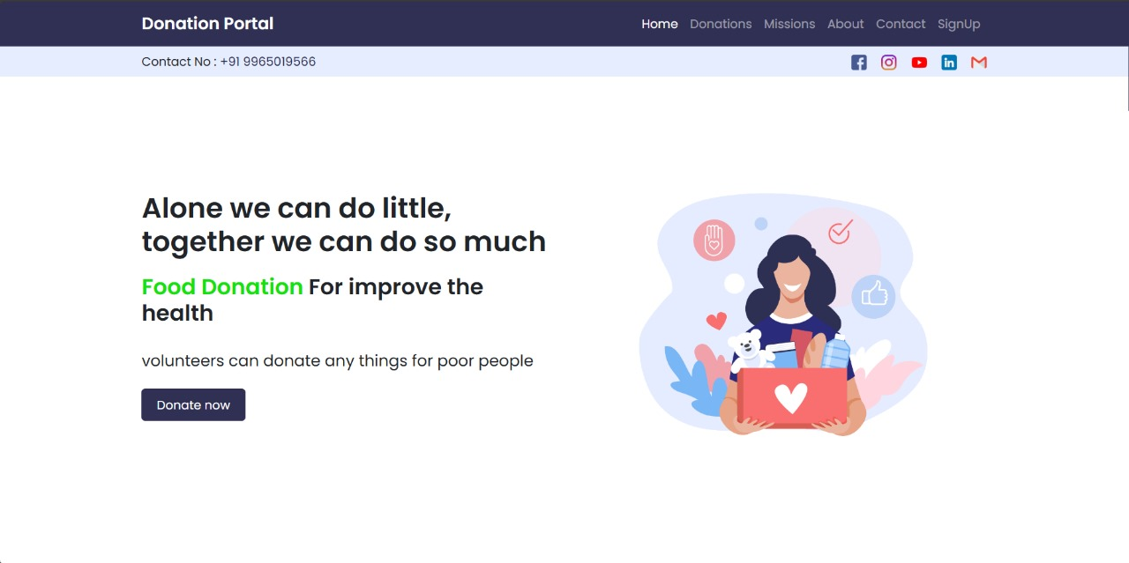

Home page

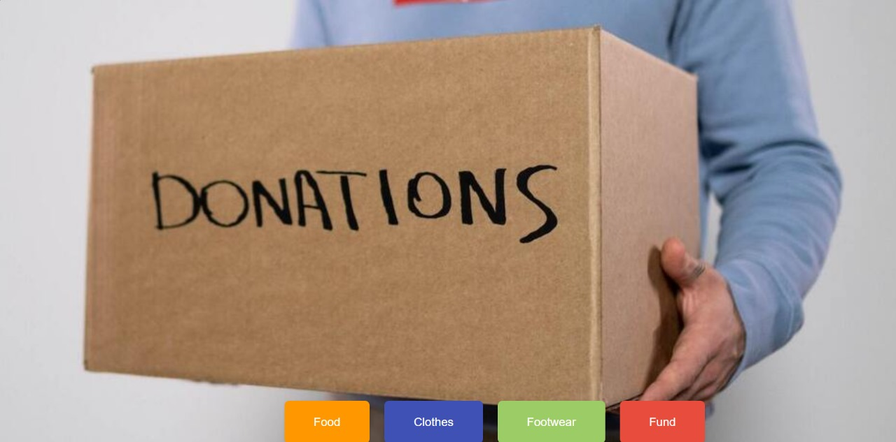

Donation type selection template

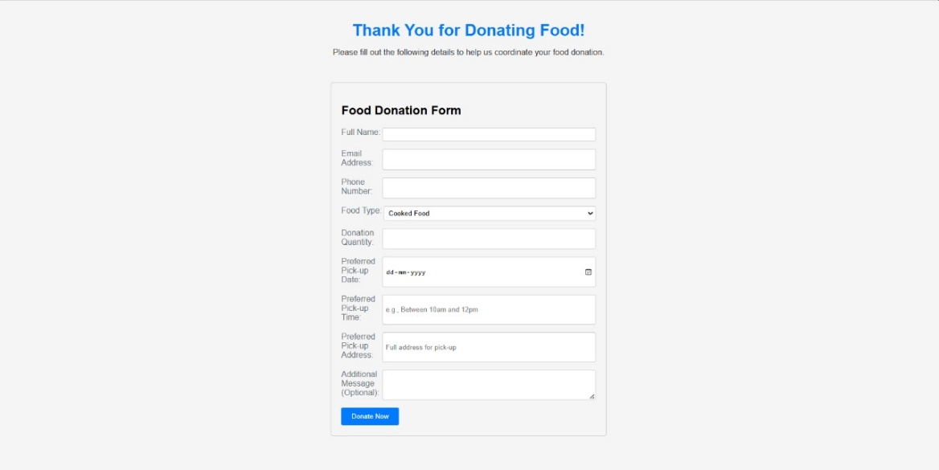

Donation Detail Form

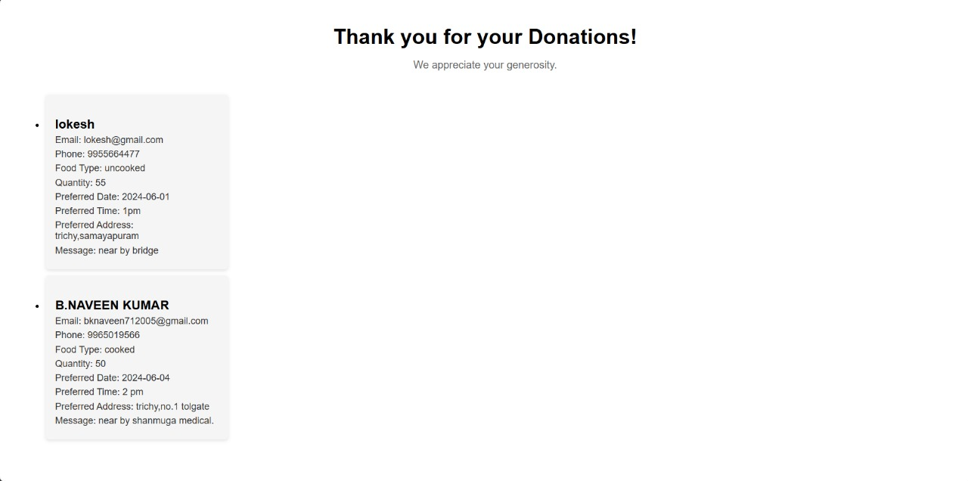

Donor Details

**9.3 REFERENCE**

* Smith, J. (2020). "Optimizing User Experience in Online Donation Platforms: A Review of Best Practices." Journal of User Interface Design, 15(2), 123-140.
* Brown, E., & Patel, C. (2019). "Designing Effective Donation Interfaces: Insights from User-Centered Design Approaches." Proceedings of the ACM Conference on Human Factors in Computing Systems, 245-260.
* Garcia, D. (2021). "Security Measures for Online Donation Platforms: A Comprehensive Review." Journal of Information Security, 28(4), 567-582.
* Martinez, S., & White, L. (2018). "Privacy Considerations in Online Fundraising: A Survey of Current Practices and Challenges." IEEE Transactions on Dependable and Secure Computing, 14(3), 345-360.
* Johnson, M. (2019). "Maximizing Donor Contributions: Strategies for Success in Online Fundraising." Nonprofit Management and Leadership, 25(3), 421-438.
* Clark, D., et al. (2020). "The Role of Social Media in Fundraising: Insights from Successful Donation Campaigns." Journal of Marketing Research, 36(2), 189-204.
* Brown, E. (2022). "Technological Trends in Online Fundraising: A Comprehensive Overview." ACM Transactions on Internet Technology, 19(1), 78-95.
* Martinez, J., et al. (2019). "Payment Processing Systems for Nonprofit Organizations: A Comparative Study." International Conference on Information Systems, 102-117.
* Wilson, S. (2020). "Lessons Learned from High-Impact Donation Campaigns: A Case Study Analysis." Journal of Nonprofit & Public Sector Marketing, 27(3), 345-360.
* Nguyen, H., et al. (2021). "Innovative Features in Donation Portals: Case Studies from Leading Platforms." International Journal of Electronic Commerce, 15(4), 501-516.
* TechSoup: <https://www.techsoup.org/>
* Network for Good: <https://www.networkforgood.com/>
* Blackbaud: <https://www.blackbaud.com/>
* 18. Jones, R., & Lee, S. (2018). "Database Management in Donation Portals: Challenges and Solutions." Journal of Database Management, 29(2), 245-260.
* 19. Clark, D., et al. (2019). "The Impact of Storytelling on Donor Behavior: Evidence from Online Fundraising Platforms." Journal of Consumer Psychology, 42(4), 567-582.
* Johnson, A., et al. (2023). "Evaluation Framework for Donation Portals: A Case Study Approach." International Journal of Information Management, 35(2), 189-204.